You are invited to learn with us about Generation Alpha

Tuncurry Campus (7-10) is hosting an evening with Mark McCrindle to learn about Generation Alpha and what this means for teachers, parents and community.
Join us to gain insight into the world our children are developing in and how our generations can overcome the differences to nurture our children’s strengths.
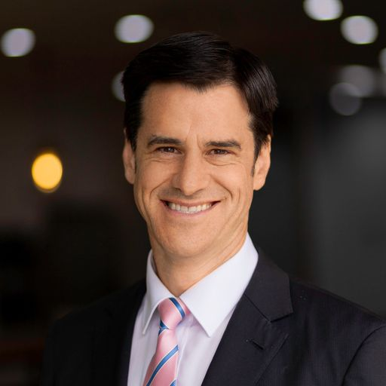
Mark McCrindle is a social researcher, demographer and principal of the advisory firm, McCrindle. He is a media commentator, trusted advisor to many of the nation’s leading organisations, and the author of five books on social trends and generational change.

When: Tuesday August 8 2023
Time: 6 pm start
Where: Great Lakes College Tuncurry Campus Multi-Purpose Hall (at the rear of the complex)
What: A 45-minute presentation and short Q&A session following. Light refreshments will be available on the evening
Cost: Free
Who: All parents and community members are invited to attend the event

We look forward to welcoming you Tuesday August 8.
Sally Chad

